**Using Conda Environments**

# Installing Conda

The easiest way to install the Conda tooling so that you can manage Conda environments is to install Anaconda.

To download Anaconda (which includes Conda) use:

<https://www.anaconda.com/products/individual>

Next if you have a terminal window open – open a new one for the conda command to be picked up.

# Using Conda

Now try the command

conda info

You should now see information about the conda (and Anaconda) configuration on your computer.

You can now create a new Conda environment. You can do this using the conda create command. This takes a –name option which allows you to specify the name of the environment, for example:

conda create --name myvenv

You can also specify the version of Python to use with the environment for example:

conda create --name myvenv python=3.6

Once you have one or more environment available. You can activate a named Conda environment. Activation is used to set up your Terminal or Command window to use that environment:

conda activate myvenv

You can now check to see which version of Python is being used. You should find that it is a version of Python associated with your current Conda environment.

which -a python

python --version

You can deactivate your conda environment using

conda deactivate

To install a library / package using conda use conda install, for example:

conda install pytest

To see what libraries / packages are installed for the current conda environment use:

conda list

If you want to see what conda environments you have available use

conda info --env

You can also update the version of Python in a conda environment using

conda install python=3.8

Remove an environment using

conda env remove -n ENV_NAME

# Updating conda to the current version

To update conda, in your terminal window or an Anaconda Prompt, run:

conda update conda

Conda compares versions and reports what is available to install. It also tells you about other packages that will be automatically updated or changed with the update. If conda reports that a newer version is available, type y to update:

Proceed ([y]/n)? y

# Quick Reference for Conda

Quick reference cheat sheet for Conda

https://docs.conda.io/projects/conda/en/latest/user-guide/cheatsheet.html

# Using Conda with PyCharm

You can also access your conda environments / create a conda environment using PyCharm. For example, when you create a New project you can select Conda as the type of Virtual Environment you want to use and specify a new virtual environment to use with the project, for example:

You can then interactively add new libraries to this environment using the PyCharm>Preferences… menu option:

This will display the Preferences dialog. In the left-hand tree open the Project node and select the ‘Python Interpreter’ option:

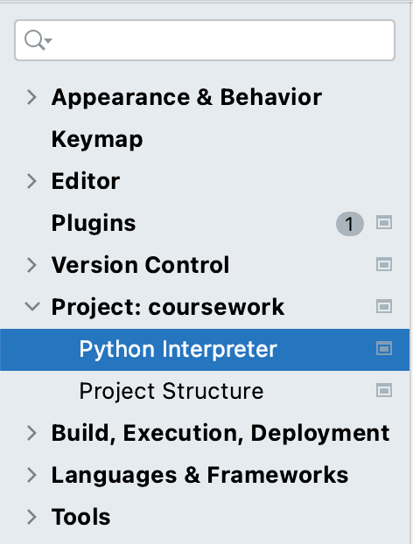

This will display the current set up for the Python interpreter used with this project as well as the libraries / packages currently loaded.

You can add further packages by selecting the ‘+’ button below the selected python interpreter:

For example, if you select the ‘+’ button and type matplotLib into the Available Packages dialog that is displayed, you can select to ‘install this Package.

